**“Experiment – 5”**

Name: **SUMIT KUMAR** UID: **20BCS8226**

Branch: **BE-CSE** Section/Group: **MM 808 A**

Semester: **5th** Date of Submission: **23/10/22**

Subject Name: **Machine Learning Lab** Subject Code: **20CSP-317**

**1. Aim/Overview of the practical:**

Implement Naïve Bayes on any Dataset.

**2. Task to be done/ Which logistics used:**

Implement Naïve Bayes on any data set using sklearn.

**3. Steps for experiment/practical/Code:**

from google.colab import drive

drive.mount('/content/drive')

# importing the libraries

import numpy as np

import matplotlib.pyplot as plt

import pandas as pd

import seaborn as sns

# importing the dataset

dataset = pd.read_csv('/content/drive/MyDrive/Data/NaiveBayes.csv')

# split the data into inputs and outputs

X = dataset.iloc[:, [0,1]].values

y = dataset.iloc[:, 2].values

# training and testing data

from sklearn.model_selection import train_test_split

# assign test data size 25%

X_train, X_test, y_train, y_test =train_test_split(X,y,test_size= 0.25, random_state=0)

# importing standard scaler

from sklearn.preprocessing import StandardScaler

# scalling the input data

sc_X = StandardScaler()

X_train = sc_X.fit_transform(X_train)

X_test = sc_X.fit_transform(X_test)

# importing classifier

from sklearn.naive_bayes import BernoulliNB

# initializaing the NB

classifer = BernoulliNB()

# training the model

classifer.fit(X_train, y_train)

# testing the model

y_pred = classifer.predict(X_test)

# importing accuracy score

from sklearn.metrics import accuracy_score

# printing the accuracy of the model

print(accuracy_score(y_pred, y_test))

# import Gaussian Naive Bayes classifier

from sklearn.naive_bayes import GaussianNB

# create a Gaussian Classifier

classifer1 = GaussianNB()

# training the model

classifer1.fit(X_train, y_train)

# testing the model

y_pred1 = classifer1.predict(X_test)

# importing accuracy score

from sklearn.metrics import accuracy_score

# printing the accuracy of the model

print(accuracy_score(y_test,y_pred1))

# importing the required modules

import seaborn as sns

from sklearn.metrics import confusion_matrix

# passing actual and predicted values

cm = confusion_matrix(y_test, y_pred)

# true write data values in each cell of the matrix

sns.heatmap(cm, annot=True)

plt.savefig('confusion.png')

# importing classification report

from sklearn.metrics import classification_report

# printing the report

print(classification_report(y_test, y_pred))

# importing the required modules

import seaborn as sns

from sklearn.metrics import confusion_matrix

# passing actual and predicted values

cm = confusion_matrix(y_test, y_pred1)

# true write data values in each cell of the matrix

sns.heatmap(cm,annot=True)

plt.savefig('confusion.png')

# importing classification report

from sklearn.metrics import classification_report

# printing the report

print(classification_report(y_test, y_pred1))

# assigning features and label variables

weather = ['Sunny','Sunny','Overcast','Rainy','Rainy','Rainy','Overcast','Sunny','Sunny', 'Rainy','Sunny','Overcast','Overcast','Rainy']

# output class

play = ['No','No','Yes','Yes','Yes','No','Yes','No','Yes','Yes','Yes','Yes','Yes','No']

# Import LabelEncoder

from sklearn import preprocessing

# creating LabelEncoder

labelCode = preprocessing.LabelEncoder()

# Converting string labels into numbers.

wheather_encoded=labelCode.fit_transform(weather)

print(wheather_encoded)

# import LabelEncoder

from sklearn import preprocessing

# creating LabelEncoder

labelCode = preprocessing.LabelEncoder()

# converting string labels into numbers.

label=labelCode.fit_transform(play)

# import Gaussian Naive Bayes model

from sklearn.naive_bayes import GaussianNB

# create a Gaussian Classifier

model = GaussianNB()

# train the model using the training sets

model.fit(wheather_encoded, label)

# importing numpy module

import numpy as np

# converting 1D array to 2D

weather_2d = np.reshape(wheather_encoded, (-1, 1))

# import Gaussian Naive Bayes model

from sklearn.naive_bayes import GaussianNB

# create a Gaussian Classifier

model = GaussianNB()

# train the model using the training sets

model.fit(weather_2d, label)

# predicting the odel

predicted= model.predict([[0]]) # 0:Overcast

# printing predicted value

print(predicted)

# import scikit-learn dataset library

from sklearn import datasets

# load dataset

dataset = datasets.load_wine()

# print the names of the 13 features

print ("Inputs: ", dataset.feature_names)

# print the label type of wine

print ("Outputs: ", dataset.target_names)

# print the wine data features

print(dataset.data[0:3])

# print the wine labels

print(dataset.target)

# import train_test_split function

from sklearn.model_selection import train_test_split

# input and outputs

inputs = dataset.data

outputs = dataset.target

# split dataset into training set and test set

X_train, X_test, y_train, y_test = train_test_split(inputs, outputs, test_size=0.3, random_state=1)

# import Gaussian Naive Bayes model

from sklearn.naive_bayes import GaussianNB

# create a Gaussian Classifier

classifer = GaussianNB()

# train the model using the training sets

classifer.fit(X_train, y_train)

# predict the response for test dataset

y_pred = classifer.predict(X_test)

# import scikit-learn metrics module for accuracy calculation

from sklearn import metrics

# printing accuracy

print("Accuracy:", metrics.accuracy_score(y_test, y_pred))

# importing the required modules

import seaborn as sns

from sklearn.metrics import confusion_matrix

# passing actual and predicted values

cm = confusion_matrix(y_test, y_pred)

# true Write data values in each cell of the matrix

sns.heatmap(cm, annot=True)

plt.savefig('confusion.png')

# Importing classification report

from sklearn.metrics import classification_report

# printing the report

print(classification_report(y_test, y_pred))

# importring modules

import matplotlib.pyplot as plt

import pandas as pd

# importing the dataset

dataset = pd.read_csv('/content/drive/MyDrive/Data/NaiveBayes.csv')

# split the data into inputs and outputs

X = dataset.iloc[:, [0,1]].values

y = dataset.iloc[:, 2].values

# training and testing data

from sklearn.model_selection import train_test_split

# assign test data size 25%

X_train, X_test, y_train, y_test =train_test_split(X, y, test_size=0.25, random_state=0)

# importing StandardScaler

from sklearn.preprocessing import StandardScaler

# scalling the input data

sc_X = StandardScaler()

X_train = sc_X.fit_transform(X_train)

X_test = sc_X.fit_transform(X_test)

# importing bernoulli NB

from sklearn.naive_bayes import BernoulliNB

# initializaing the NB

classifer=BernoulliNB()

# training the model

classifer.fit(X_train, y_train)

# testing the model

y_pred = classifer.predict(X_test)

# importing accuracy score

from sklearn.metrics import accuracy_score

# printing the accuracy of the model

print(accuracy_score(y_test, y_pred))

**4. Result/Output/Writing Summary:**

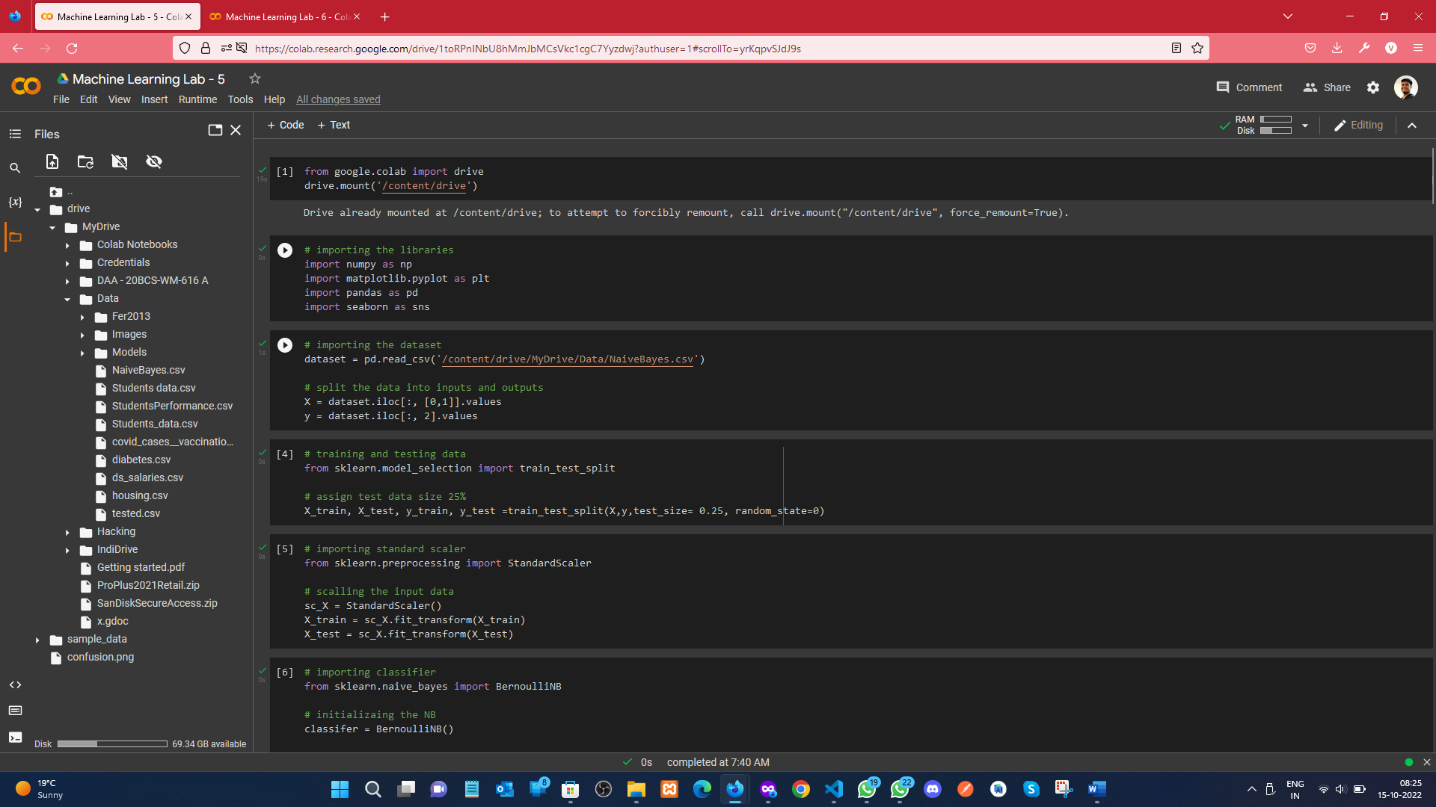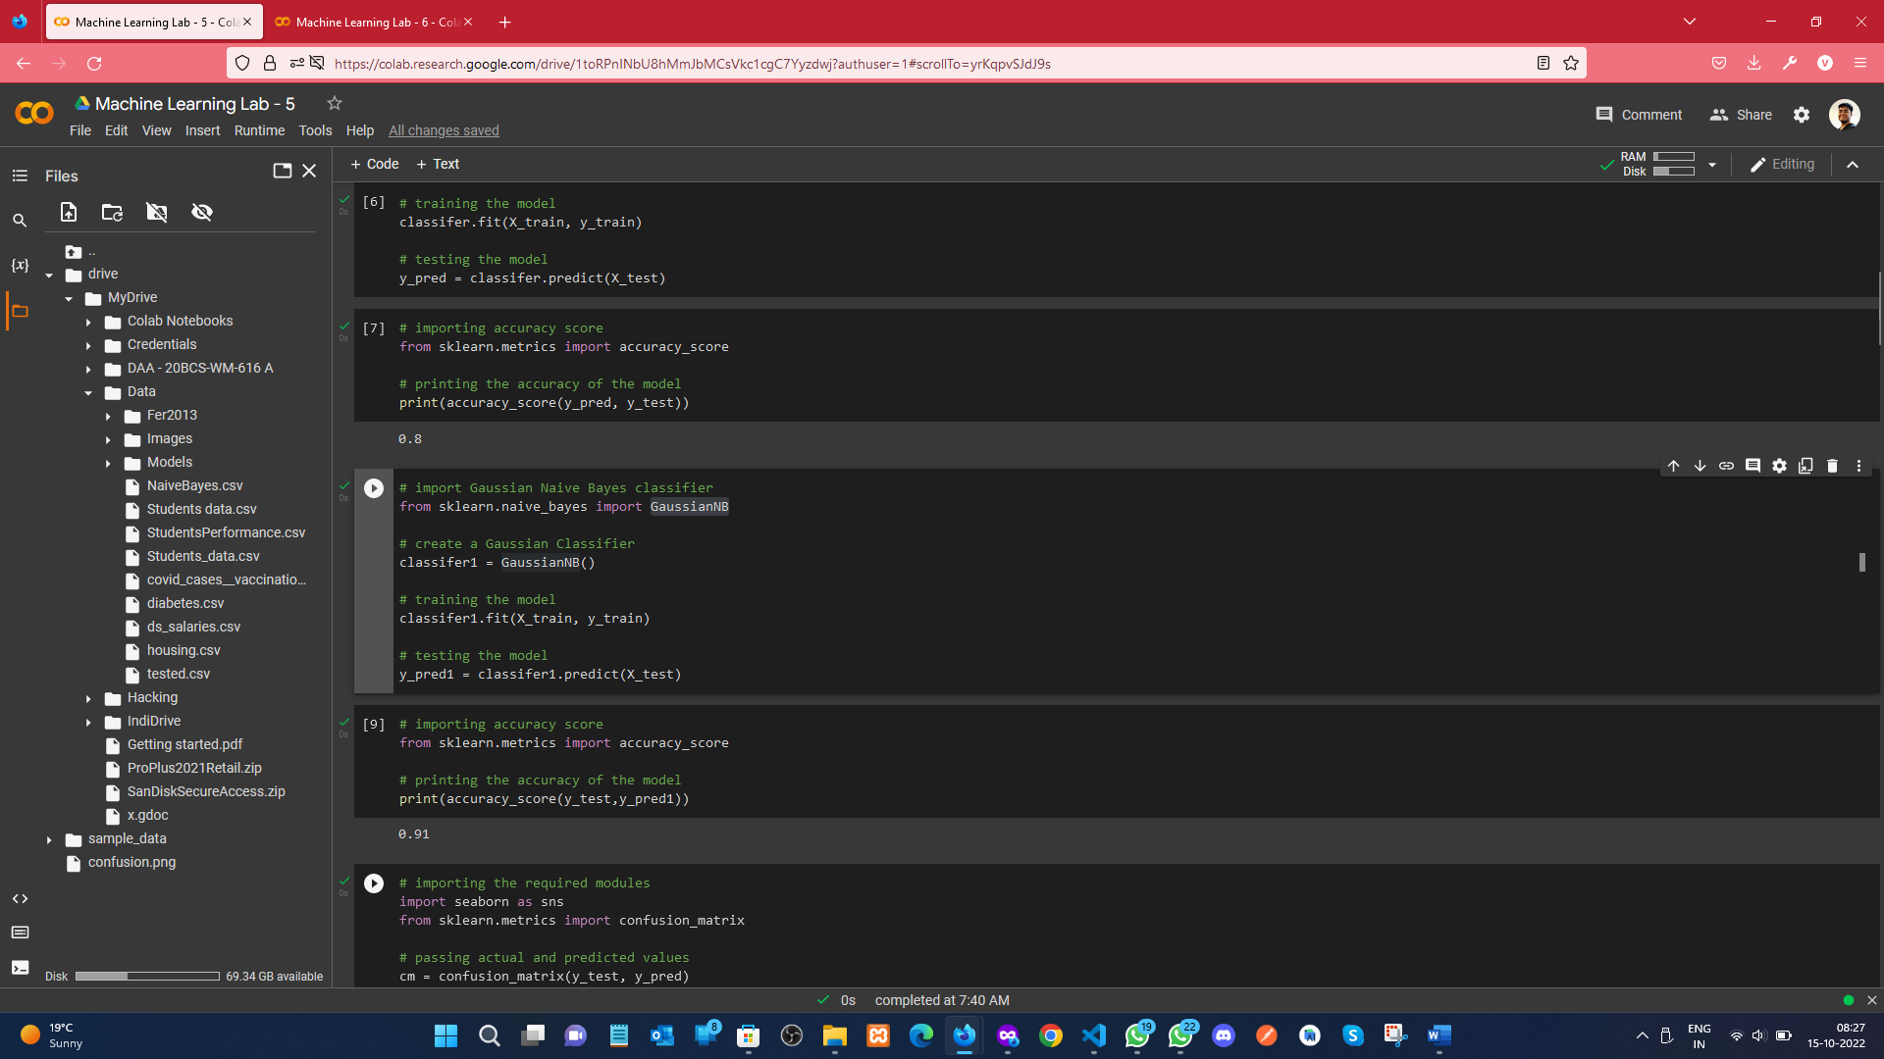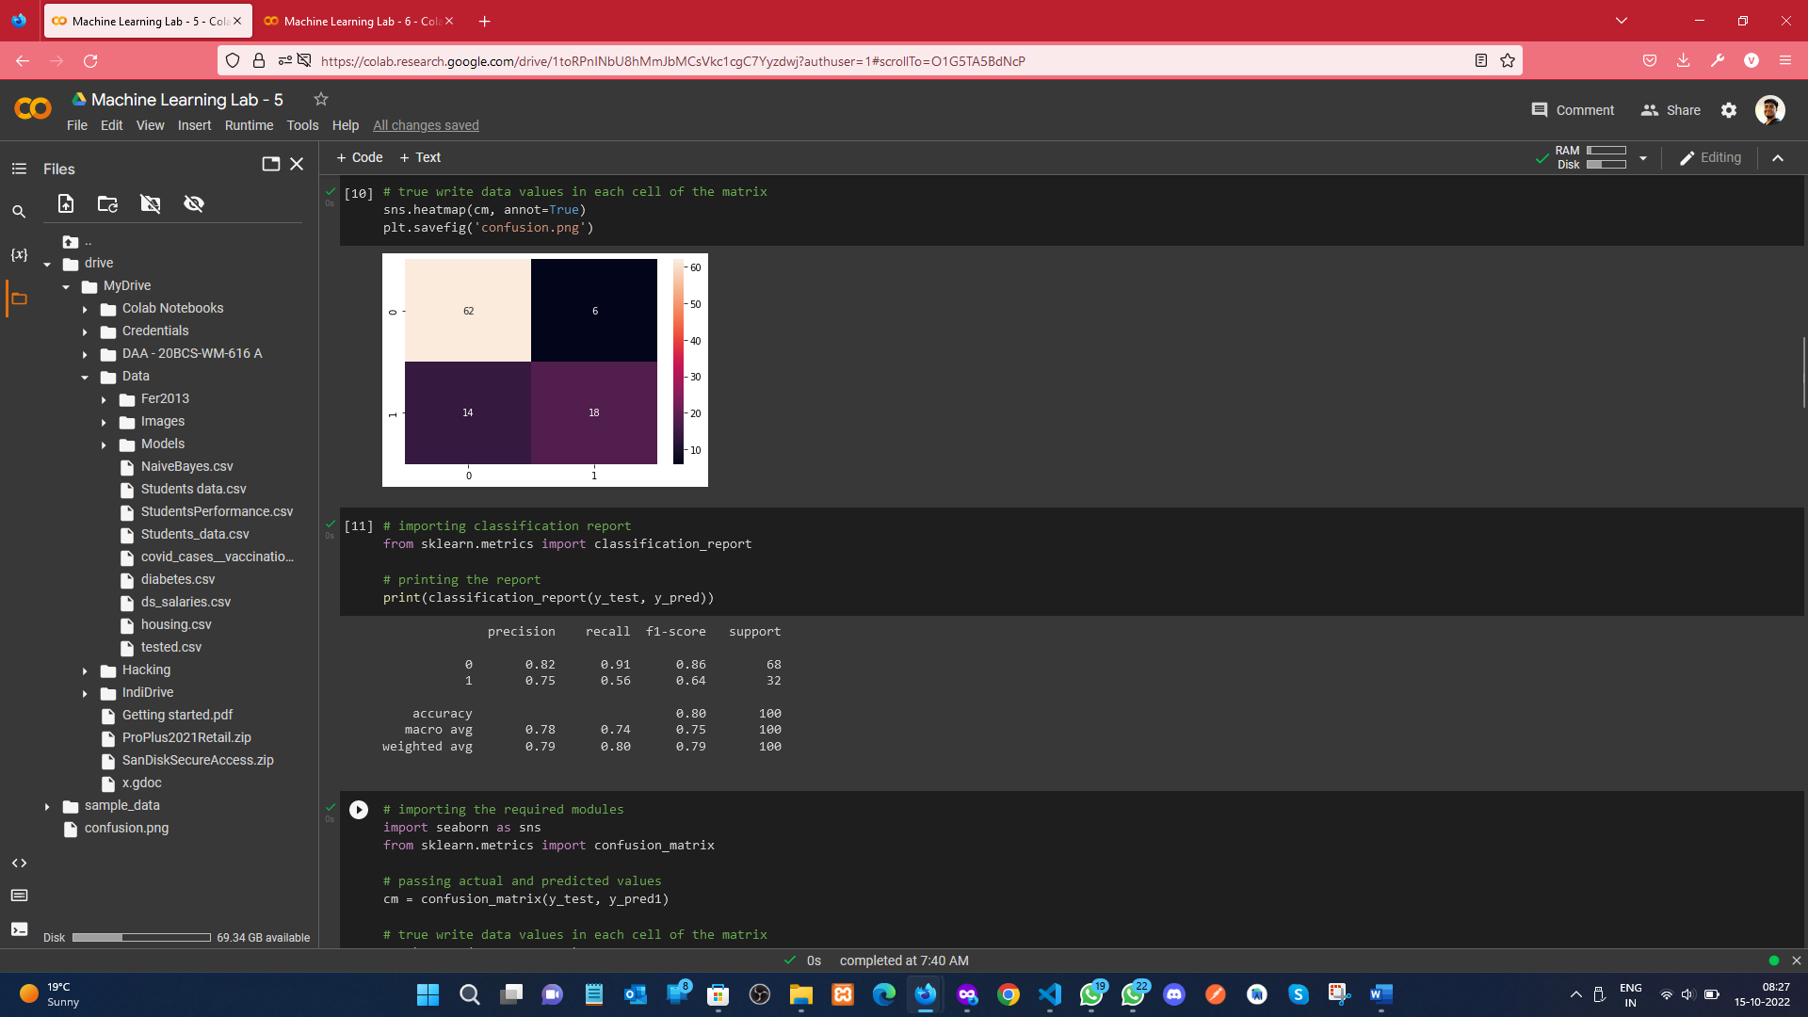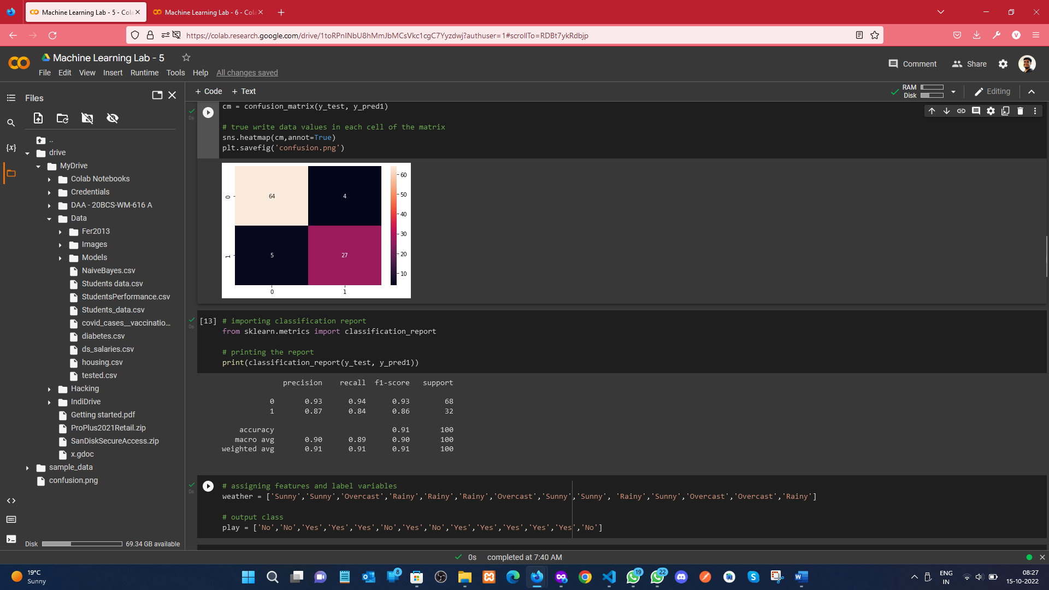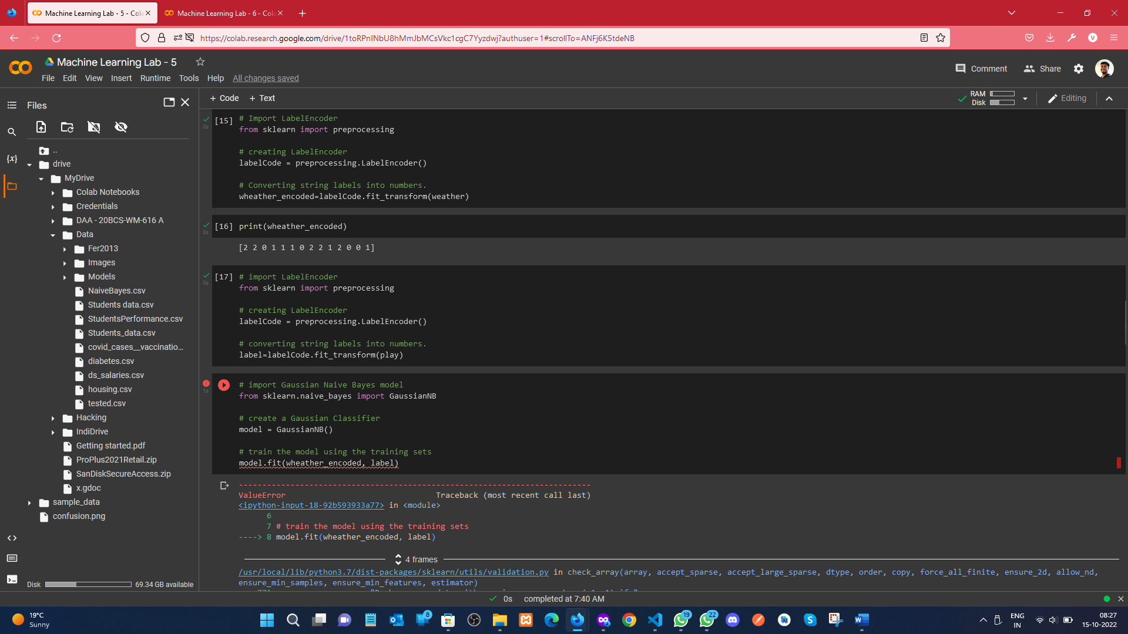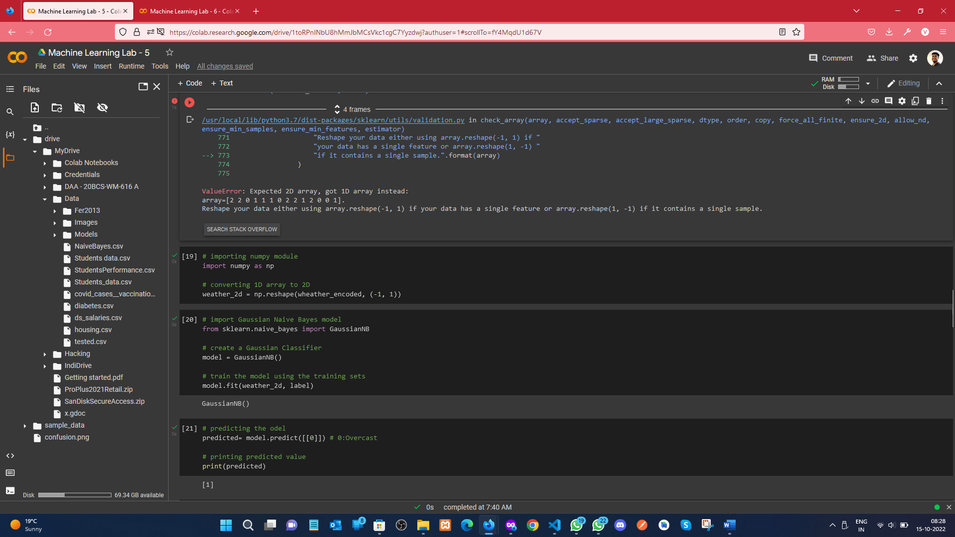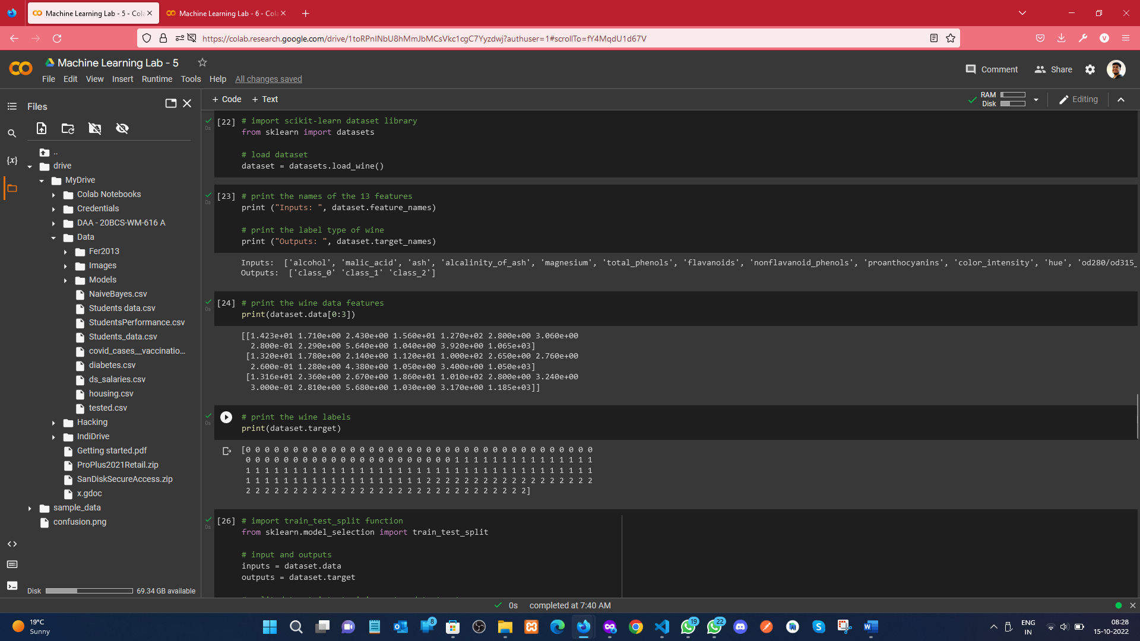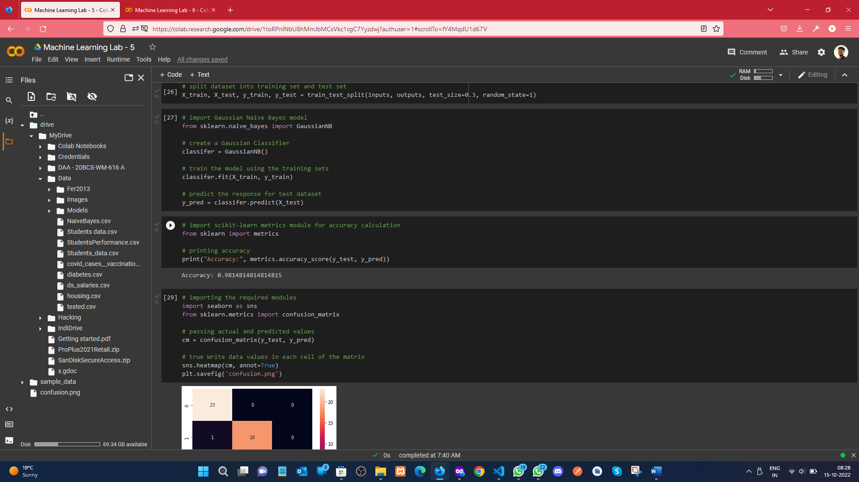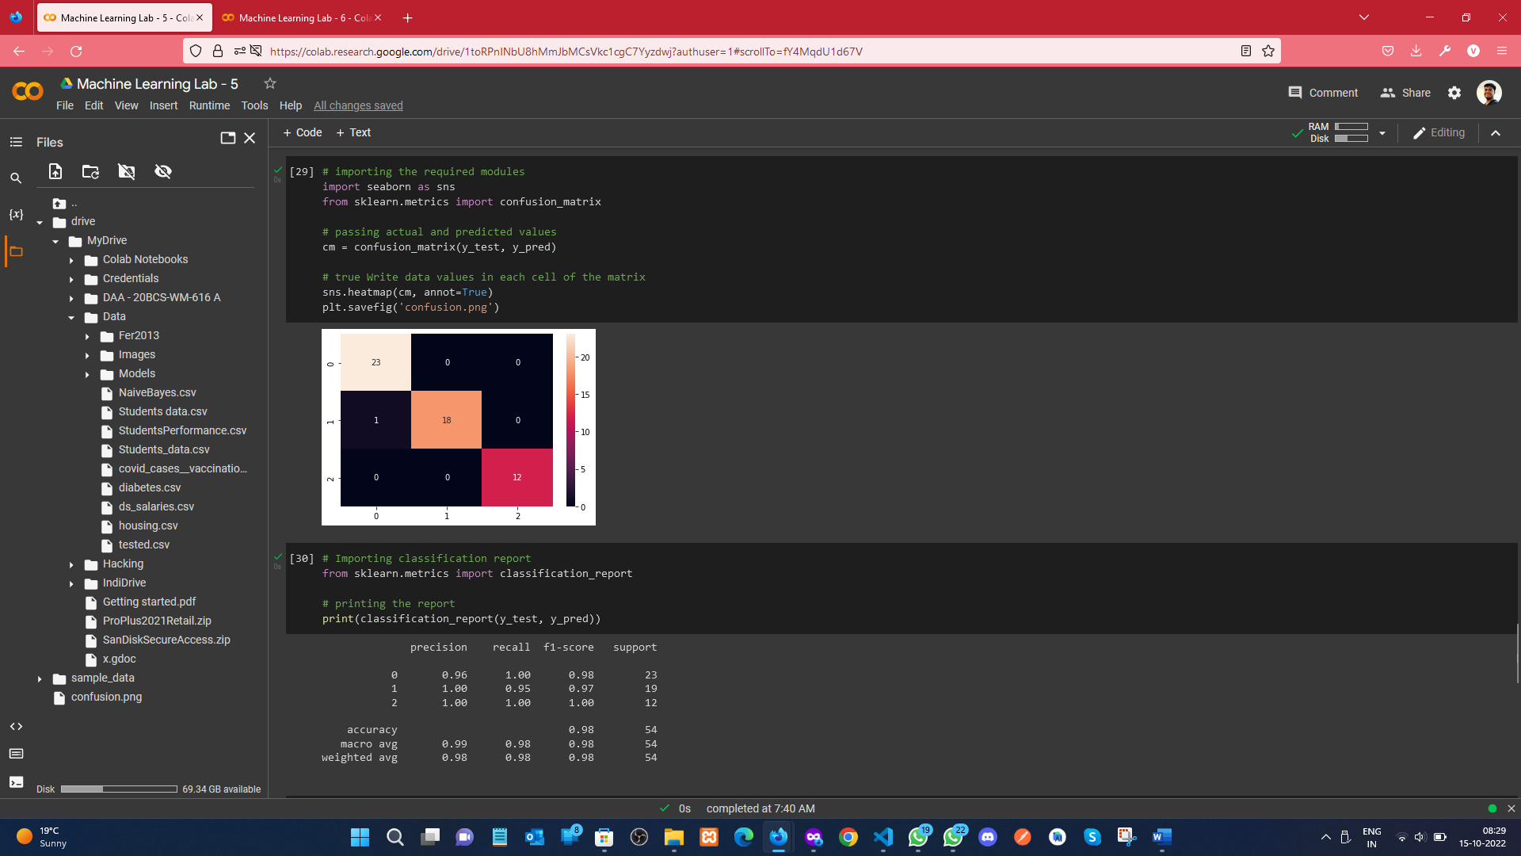

**Learning outcomes (What I have learnt):**

1. Understood the concept of Naïve Bayes (NB).
2. Learnt how to split the data into training and testing parts and perform operation on it.
3. Understood the concept of GaussianNB, BernoulliNB, and confusion matrix.
4. Finally plotted the classification report.

**Evaluation Grid (To be created as per the SOP and Assessment guidelines by the faculty):**

|  |  |  |  |
| --- | --- | --- | --- |
| Sr. No. | Parameters | Marks Obtained | Maximum Marks |
| 1. |  |  |  |
| 2. |  |  |  |
| 3. |  |  |  |
|  |  |  |  |